**Single Transaction:**

**Unlimited Transaction:**

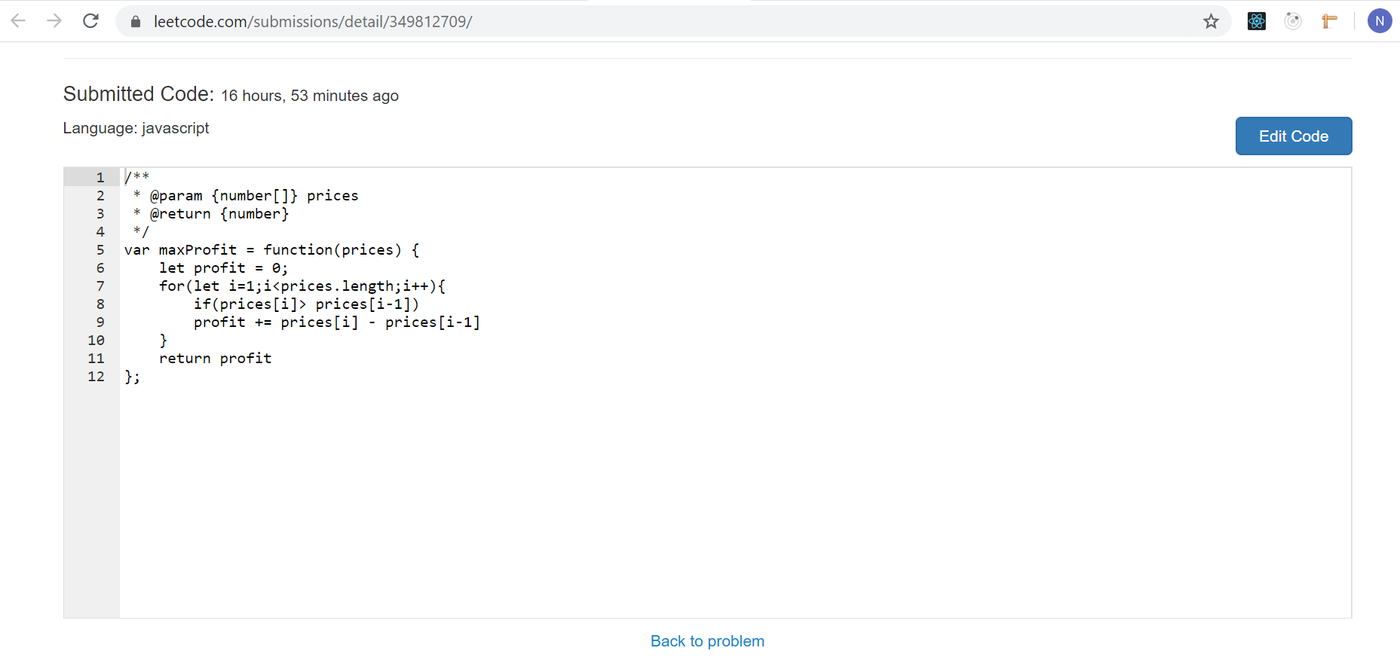

**Two Transactions:**

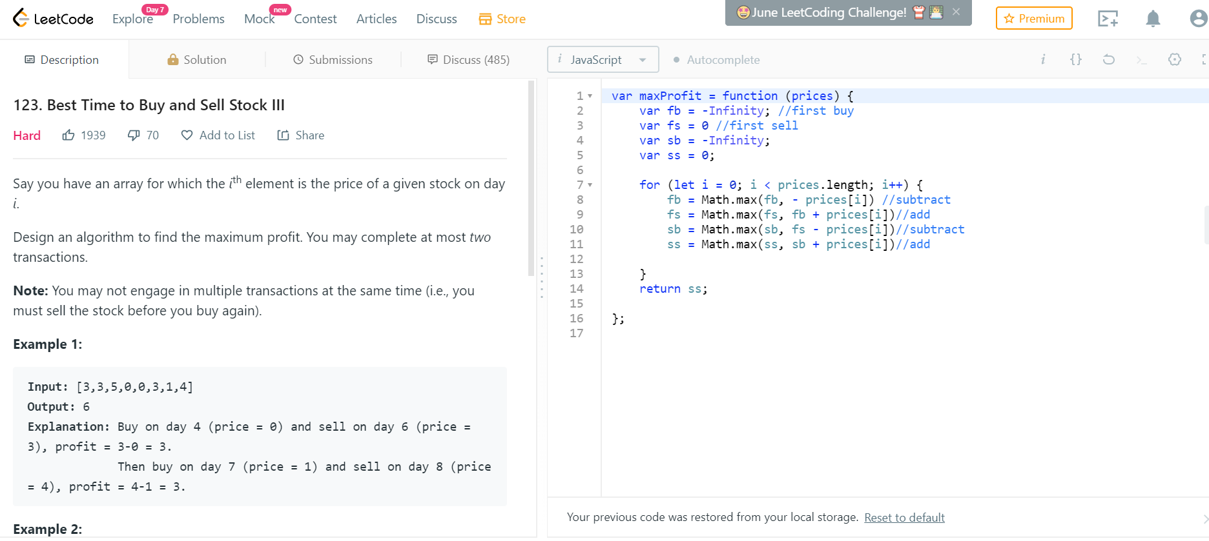

**K Transactions:**

